**Logging into your FTP client**

**Step 1 – Find a FTP Client**

Make sure that all your server files are backed up if you want to keep them.

To do this either use a FTP client like Filezilla or you can use the inbuilt file manager.

**Step 1.1 – Syte.Space FTP Config**

To start, Log into your <syte.space> account then go to configuration 🡪 SFTP Settings.

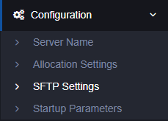

You will then see the SFTP details as shown in the picture below:

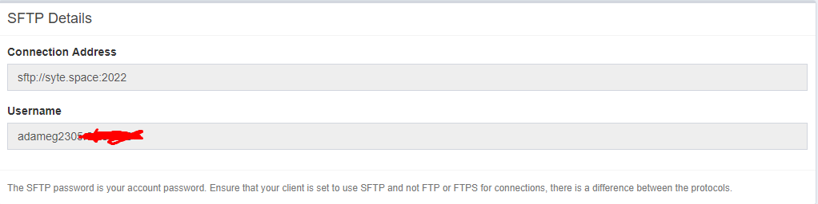

**Step 2 – Logging into FileZilla**

When you open filezilla you should see something similar to this:

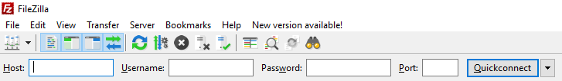

Where you see ‘Host’ you need to put your SyteSpace connection address into this box. It will look something like this: 

Then fill in Username with the username which is on the SyteSpace SFTP configuration page.

The password is your SyteSpace account password.

And the Port is 21

**Step 3 – Almost There!**

Then click quick connect which will start the connection.

You may see a popup asking if you want to connect, click yes.

**Step 4 – Done!**

Once you’ve followed the above steps you should be able to see all of your files that are in your server

**Need more help?**

Tag me in the #support server in SyteSpace (@adameg2305#6038)

PM me (@adameg2305#6038) with your issue, make sure to mention you are from the SyteSpace server, so I don’t ignore you.

Ask Anyone else on the server in case they can help you before I can.